- Make four categories; Amount, Rate, Term, and Payment
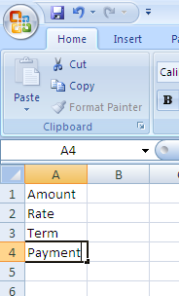
- Fill in amount, rate (decimal percentage), and Term (in months).
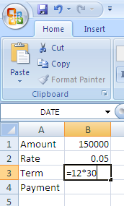
- Enter in the excel payment equation =pmt( and fill in as below)
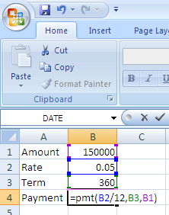

- Your sheet should look like the one below
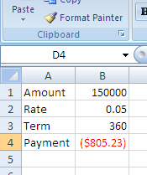
- Make the following columns
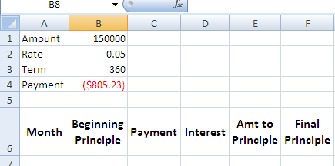
- Fill in months 1 to 360 under the months column
- Enter equation for Beginning amt
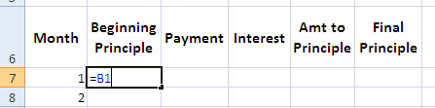
- Enter equation for payment
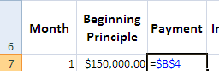
- Enter Equation for Interest paid
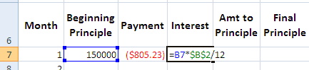
- Enter equation for amt to principle
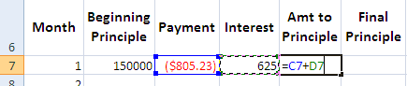
- Enter equation for final principle
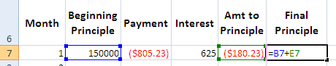
- Enter Equation for next beginning principle
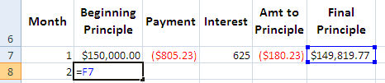
- Double click handle in bottom right corner of cell and the same equation will populate all cells below B8 with same equation to the last month.
- Double click handle in payment cell.
- Double click handle in interest cell.
- Double click handle in Amt to principle cell.
- All cells should have numbers populated and your amortization table should be complete.

